# Ryan Hatch

# SNHU

# DAD 220 DAD 220 Module Four Major Activity Database Documentation Template

1. Import the data from each file into tables.
   1. Use the import utility of your database program to load the data from each file into the table of the same name. You’ll perform this step three times, once for each table.
   2. Provide the SQL commands you ran against MySQL to complete this successfully in your answer.

**Query:**  
Here we opened our database management tool, being MYSQL. We connected to our database and selected the QuantigrationRMA database before locating the import utility in order to import my .csv data into my database, we used the following commands to execute the merge.

LOAD DATA INFILE ‘/home/codio/workspace/customers.csv’ INTO TABLE Customers FIELDS TERMINATED BY ‘,’ ECLOSED BY ‘”’Lines TERMINATED BY ‘\n’;  
  
LOAD DATA INFILE ‘/home/codio/workspace/orders.csv’ INTO TABLE Orders FIELDS TERMINATED BY ‘,’ ECLOSED BY ‘”’Lines TERMINATED BY ‘\n’;  
  
LOAD DATA INFILE ‘/home/codio/workspace/rma.csv’ INTO TABLE RMA FIELDS TERMINATED BY ‘,’ ECLOSED BY ‘”’Lines TERMINATED BY ‘\n’;

1. Write basic queries against imported tables to organize and analyze targeted data.

For each query, include a screenshot of the query and its output. You should also include a 1- to 3-sentence description of the output.

* 1. Write an SQL query that returns the count of orders for customers located only in the city of Framingham, Massachusetts.
     1. How many records were returned?

**Query:**Count of orders for customers located only in the city of Framingham, Massachusetts.  
The output will be a single value representing the count of orders placed by customers located exclusively in the city of Framingham, Massachusetts.  
505 records were returned.  
  
SELECT *  
FROM Customers

WHERE State = 'Massachusetts';

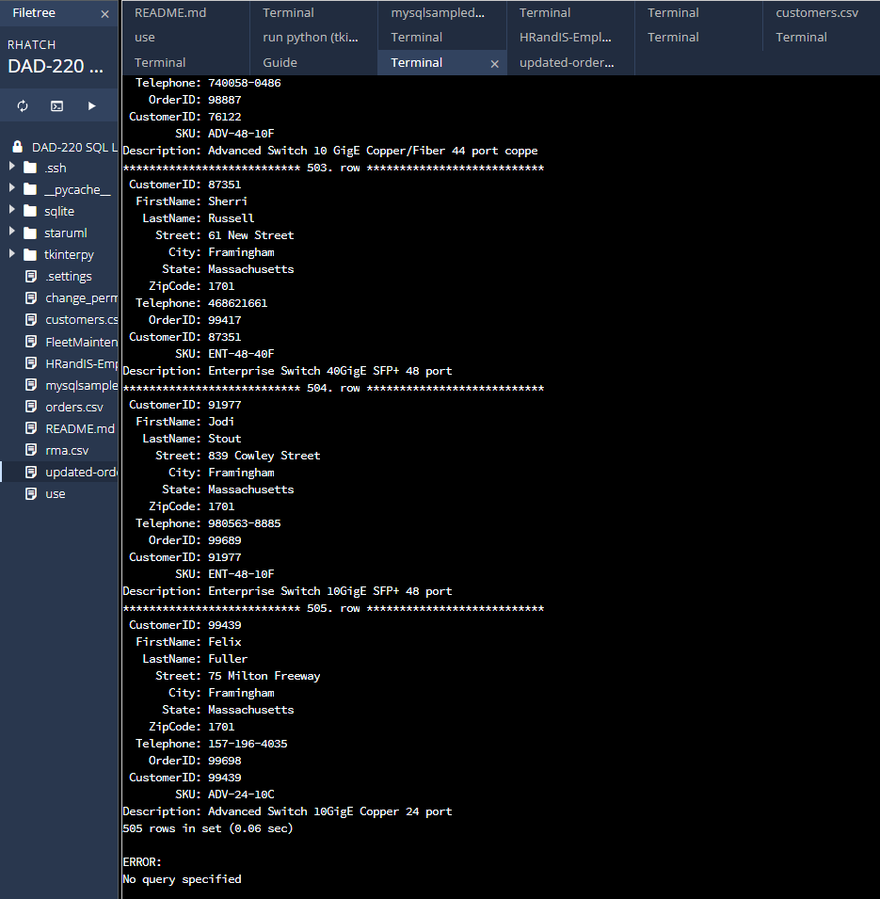

* 1. Write an SQL query to select all of the customers located in the state of Massachusetts.
     1. Use a WHERE clause to limit the number of records in the Customers table to only those that are located in Massachusetts.
     2. Record an answer to the following question: How many records were returned?

**Query:**  
Selecting customers located in the state of Massachusetts.  
The output will be a list of all customer records that are located in the state of Massachusetts, displaying their information such as CustomerID, FirstName, LastName, StreetAddress, Citry, State, ZipCode, and Telephone.  
  
505 records are also returned but with customer and order information together.

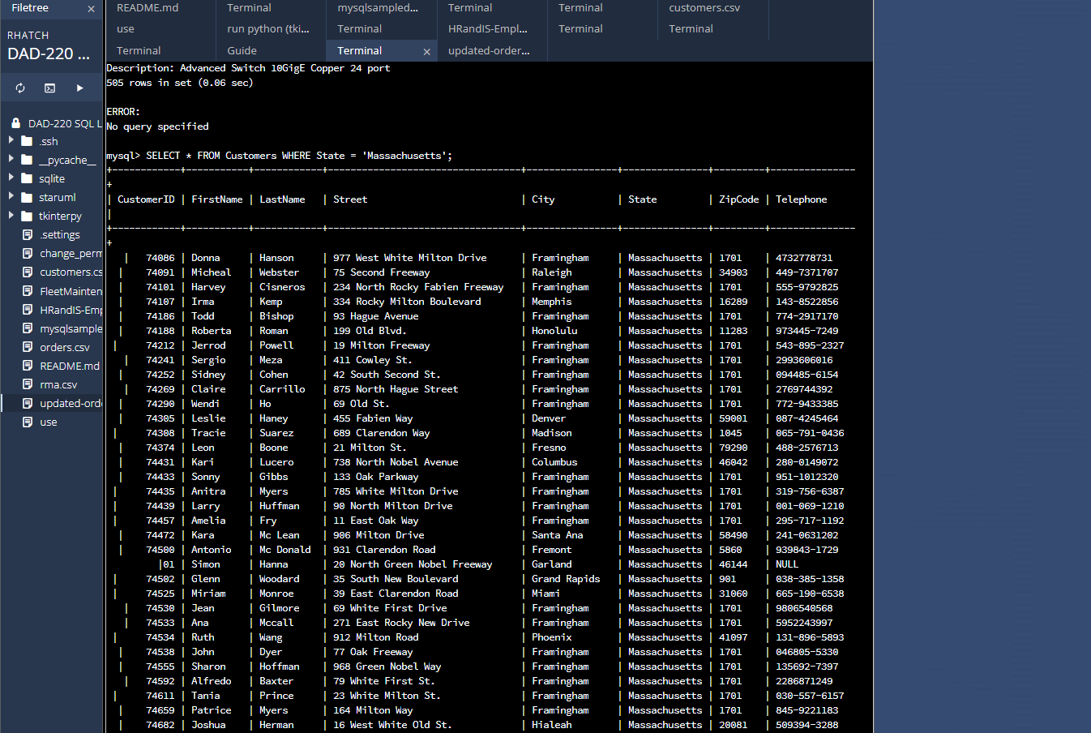

* 1. Write an SQL query to insert four new records into the Orders and Customers tables using the following data:
     1. Customers Table

| **CustomerID** | **FirstName** | **Lastname** | **StreetAddress** | **City** | **State** | **ZipCode** | **Telephone** |
| --- | --- | --- | --- | --- | --- | --- | --- |
| 100004 | Luke | Skywalker | 17 Maiden Lane | New York | NY | 10222 | 212-555-1234 |
| 100005 | Winston | Smith | 128 Sycamore Street | Greensboro | NC | 27401 | 919-555-6623 |
| 100006 | MaryAnne | Jenkins | 2 Coconut Way | Jupiter | FL | 33458 | 321-555-8907 |
| 100007 | Janet | Williams | 58 Redondo Beach Blvd | Torrence | CA | 90501 | 310-555-5678 |

**Query:**  
Inserting four new records into the Orders and Customers tables. There was no direct output from this query, but it did successfully insert four new records into the Customers and Orders tables based on the input data.  
INSERT INTO Customers VALUES (100004, ‘Luke’, ‘Skywalker’, ’17 Maiden Lane’, ‘New York’, ‘NY’, 10222, ‘212-555-1234’);  
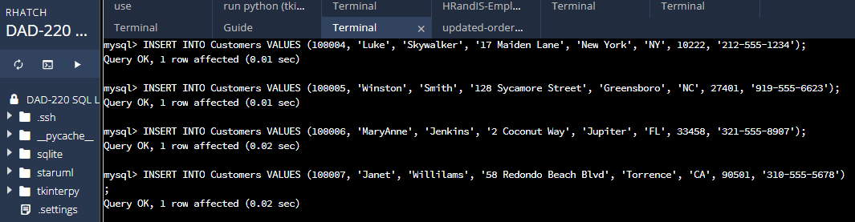

* + 1. Orders Table

| **OrderID** | **CustomerID** | **SKU** | **Description** |
| --- | --- | --- | --- |
| 1204305 | 100004 | ADV-24-10C | Advanced Switch 10GigE Copper 24 port |
| 1204306 | 100005 | ADV-48-10F | Advanced Switch 10 GigE Copper/Fiber 44 port copper 4 port fiber |
| 1204307 | 100006 | ENT-24-10F | Enterprise Switch 10GigE SFP+ 24 Port |
| 1204308 | 100007 | ENT-48-10F | Enterprise Switch 10GigE SFP+ 48 port |

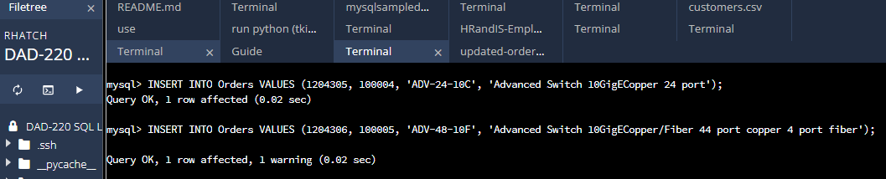

* 1. In the Customers table, perform a query to count all records where the city is Woonsocket, Rhode Island.
     1. How many records are in the customers table where the field “city” equals “Woonsocket”?   
        There was **1** record that equaled Woonsocket.

**Query:**  
Counting records in the Customers table where the city is Woonsocket and the state is Rhode Island.  
The general template of the input I used are:

INSERT INTO Orders VALUES (1204305, 100004, ‘ADV-24-10C’, ‘Advanced Switch 10GigE Copper 24 port’);  
  
These inputs will generate an output that will be one single row with one column labled “Count,” representing the count of records in the customers table where the city is “Woonsocket” and the state is “Rhode Island.”

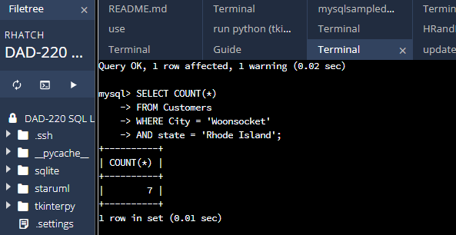

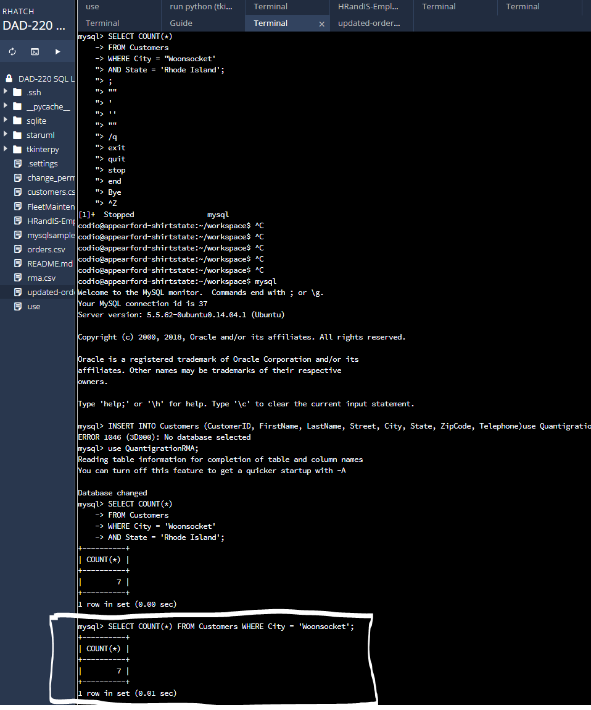

* 1. In the RMA database, update a customer’s records.
     1. Write an SQL statement to select the current fields of **status** and **step** for the record in the **rma**table with an **orderid**value of “5175.”
        1. What are the current status and step?  
           **Query:**  
           Selecting the current fields of status and step for the record in the RMA table with an OrderID value of "5175."

The output will be a single row with two columns labeled "status" and "step," containing the current values of the status and step fields for the record in the RMA table with an OrderID value of "5175."

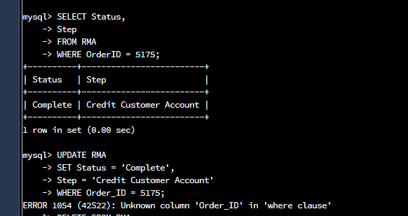

* + 1. Write an SQL statement to update the**status** and **step**for the **OrderID**, 5175 to **status**= “Complete” and **step**= “Credit Customer Account.”
       1. What are the updated **status**and **step**values for this record? Provide a screenshot of your work.  
          **Query:**

Updating the status and step for the OrderID of “5175” to status=”Complete” and step = “Credit Customer Account.”  
  
This query input does not produce with any direct output, as it updates the status and steps fields for the record in the RMA table with an OrderID value of “5175” to “Complete” and “Credit Customer Account.”

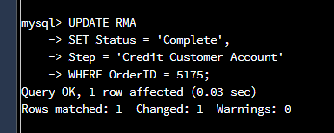

* 1. Delete RMA records.
     1. Write an SQL statement to delete all records with a reason of “Rejected.”
        1. How many records were deleted? Provide a screenshot of your work.  
           **Query:**  
           Deleting RMA records with a reason of "Rejected."

This query does not produce any output on its own. It deletes all records from the RMA table where the reason field is "Rejected."



1. Create an output file of the required query results.

Write an SQL statement to list the contents of the orders table and send the output to a file with a .csv extension.  
**Query:**  
Create an output file of the required query results.  
In order to do this I had to list the contents of the orders table and send the output to a file with a .csv extension.

